  **SkillTech International**  

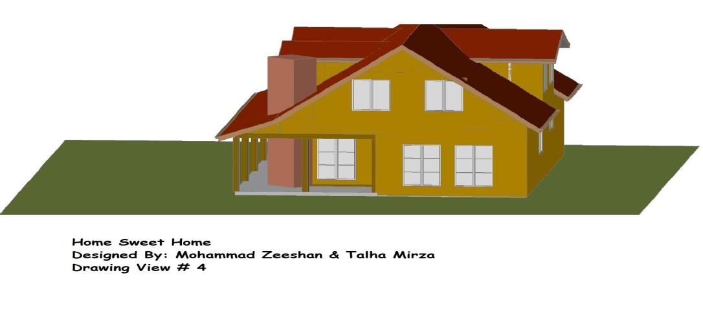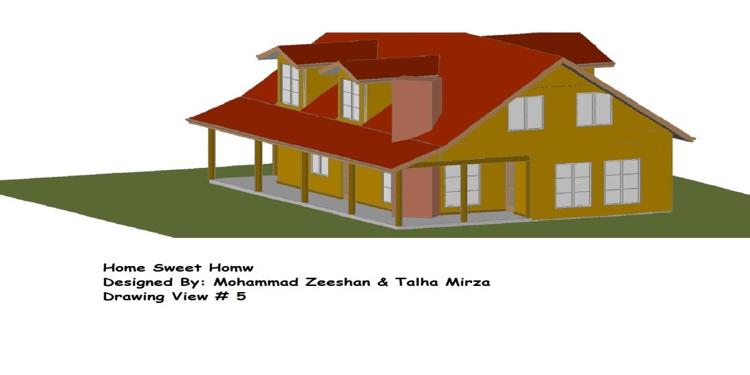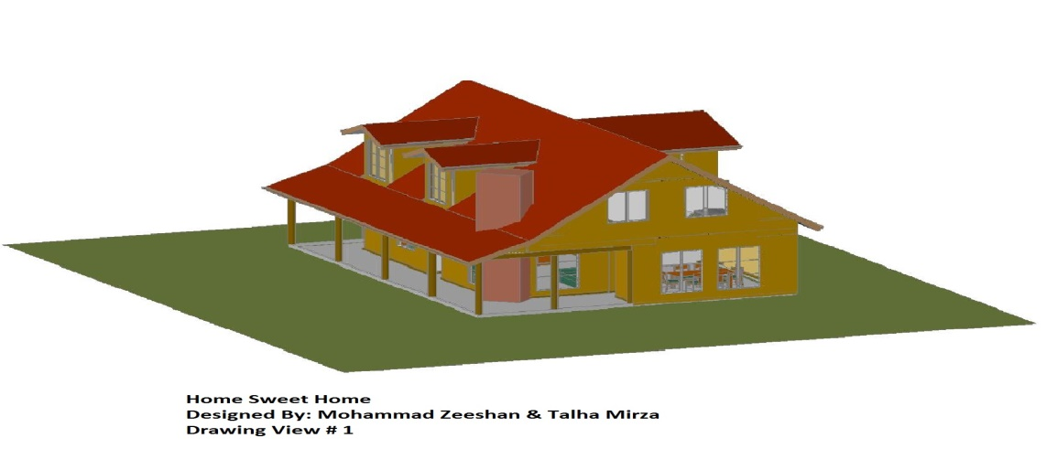

Designed By : Mohammad Zeeshan & Talhra Mirza

SupervIsed: Ayaz Hussain